**AMASS TO NAVIA(CW1)**

**INTRODUCTION**

* Processes need to be automated to increase productivity by reducing the time taken to perform the task and it enhances the production process. One of it is this process which focuses on automating consolidation.

**SCOPE**

* Automates consolidation by converting AMASS TO NAVIA(CW1).

**DEFINITION**

* This is a process wherein it automates consolidation.

**OVERVIEW**

* Automated processes are very helpful and useful to be more productive which is the reason why, this process is implemented for consolidation.

**PURPOSE**

* To increase productivity by reducing the time to perform the task and enhances production process.

**BASIC HIGH LEVEL DESIGN**

1. AMASS FTP User was created to be able to send data to be processed.  
     
   For example:  
     
   *User:* ***amassuser01*** *Password:* ***123456***
2. Based on the data that will be provided, we will be able to create a schema for AMASS and convert it to NAVIA(CW1) schema, which is shown below.  
     
     
     
     
     
   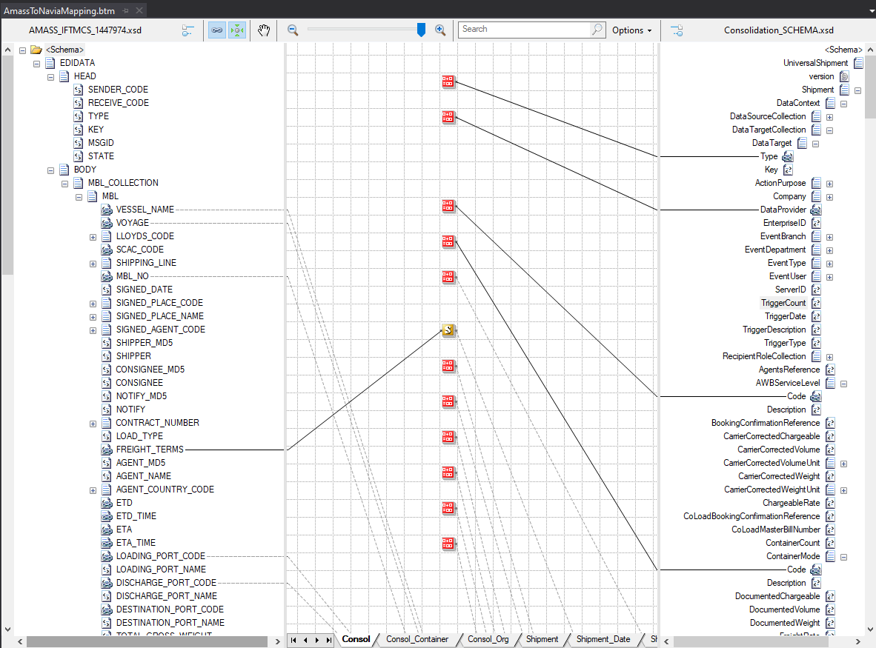  
     
     
     
     
     
     
     
     
     
     
     
     
     
     
     
   The image above also shows the mapping of AMASS schema to NAVIA(CW1) schema. The output for this will be an XML file.